AI ASSISTANT CODING - ASSIGNMENT-10.3

Name: M.Vivek
Roll No: 2303A52460 Batch: 41

Task 1: AI-Assisted Bug Detection
Prompt:
identify the the logical bug in the code of 10.3.py Code:
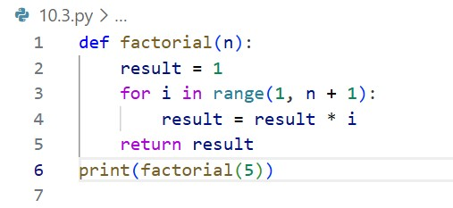
Output:
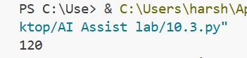
Justification:
In the code given in the scenario has the bug that is in the for loop the range is upto n so the it will run until n-1 this results the incorrect output.
The the AI fixed the bug bug by adding the n+1 in place of n in the for loop.
The AI generated code and the manual code i have fixed is the similar to each other.
The AI missed the edge case that is the if we perform the function with the negative numbers it has to get the output not defined but it is showing the -1.

Task 2: Improving Readability &Documentation
Prompt:
rewrite the function with descriptive function and parameter names and a complete docstring which includes description, parameters, return value, examples and exception handling for division by zero and consideration of input validation.
Scenario Code:
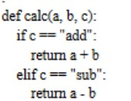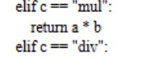

AI Corrected Code:
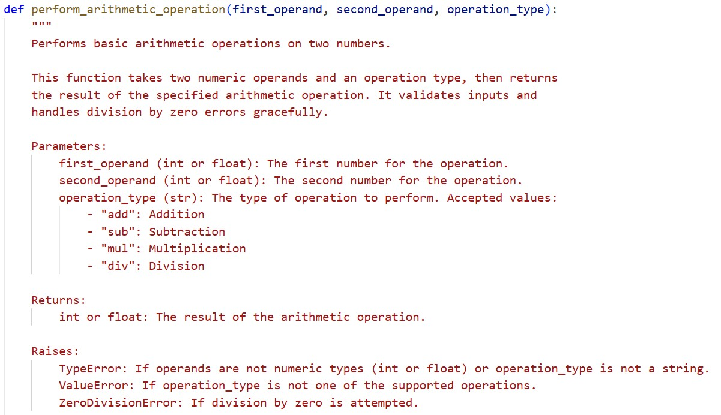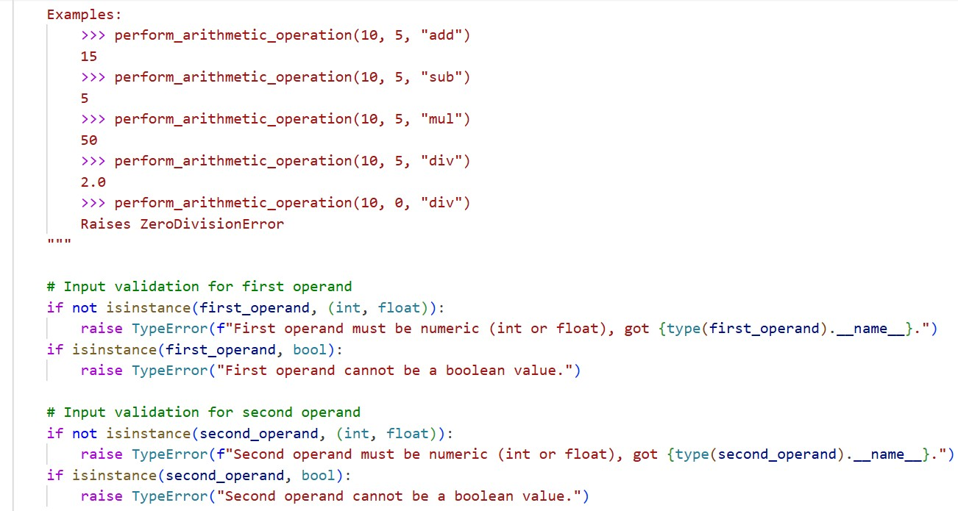
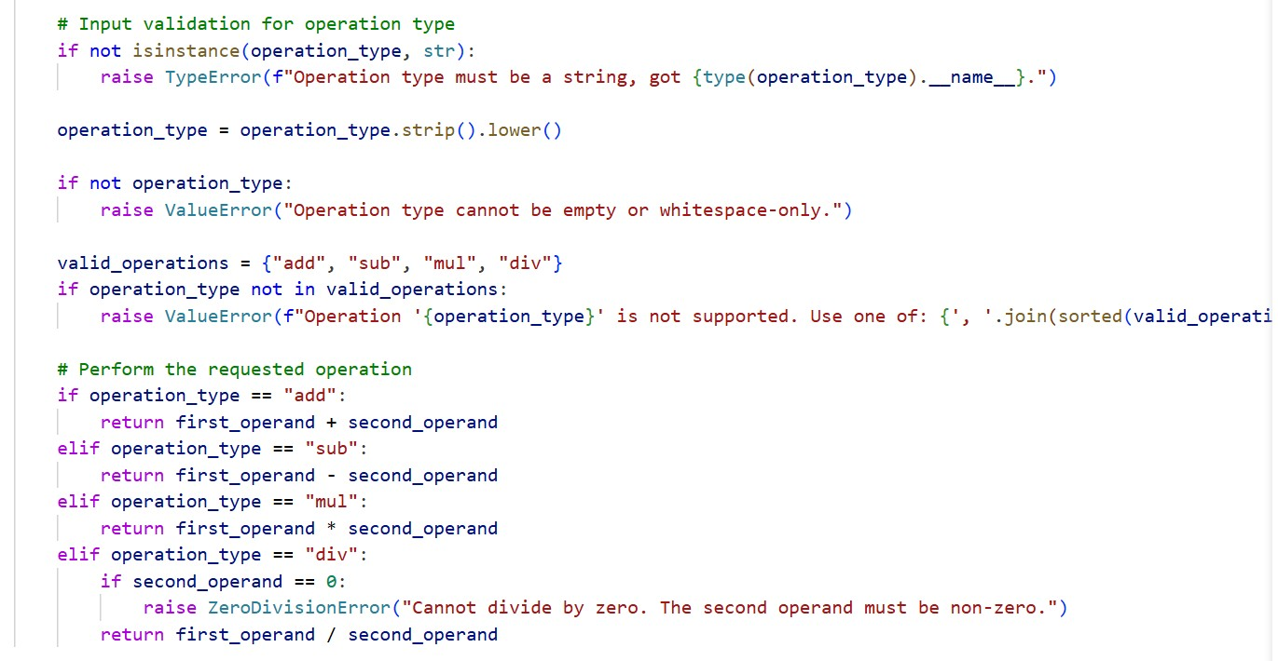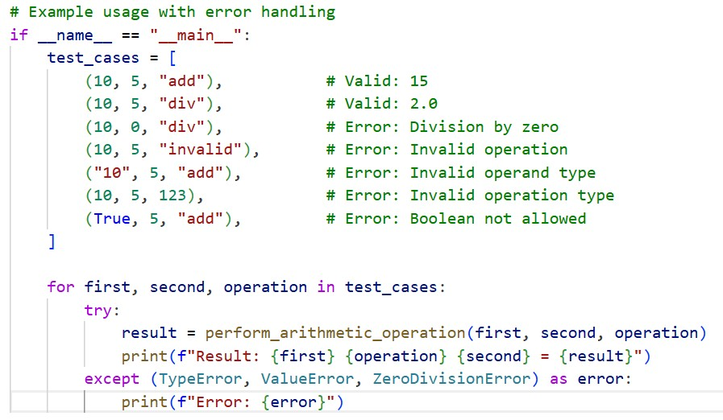

Output:
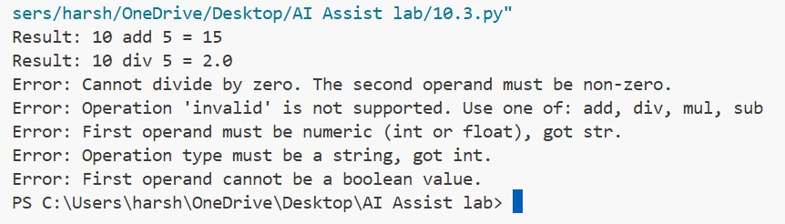

Justification:
In the above task, using the AI we have improved the code for better readability using the docstrings and the documentation and we have successfully handled the Exceptions and solved it and the AI Improved code will also handled the input validation.
I have compared the Original code and the AI-Improved code it clearly shows the difference between both the codes which the clear understanding of the AI given code using the Documentation.
The both valid and invalid inputs are working correctly with the AI given code it runs correctly.

Task 3: Enforcing Coding Standards
Prompt:
List all the PEP8 violations present in the given code and refactor the code
Code:
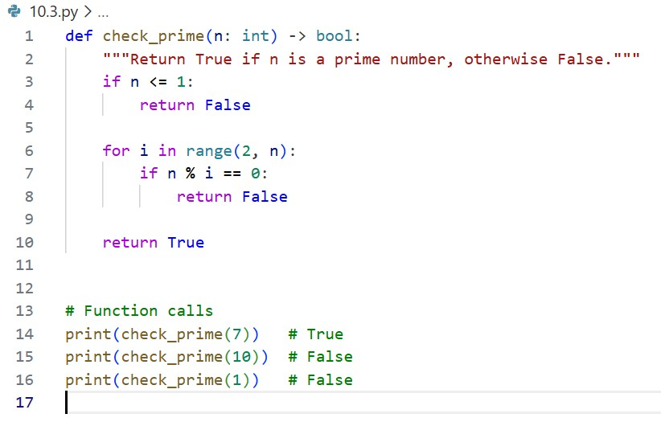
Output:
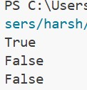
Justification:
PEP8 Violations :
- Function name not in snake_case → Checkprime should be check_prime
- Missing blank line before function definition
- No docstring provided
- Edge case not handled (n <= 1)
Automated AI reviews can significantly streamline code reviews in large teams by instantly detecting style violations, logical bugs, and performance issues. AI tools enforce consistent coding standards like PEP8 without human bias and reduce reviewer workload. This allows developers to focus on architecture and design decisions instead of minor formatting corrections. As a result, teams achieve faster review cycles, cleaner codebases, and improved collaboration.

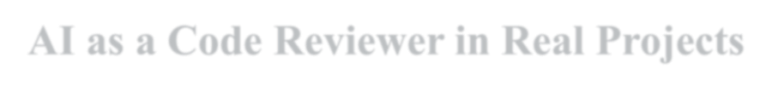

Task 4: AI as a Code Reviewer in Real Projects
Prompt:
Refactor and improve the code in file by renaming for clarity purposes, and suggest generalization.
Code:
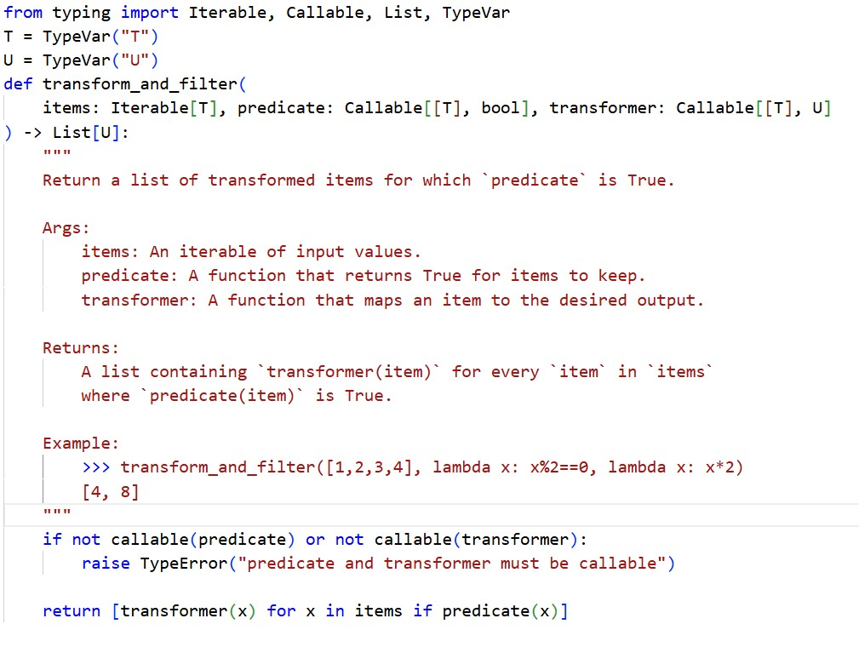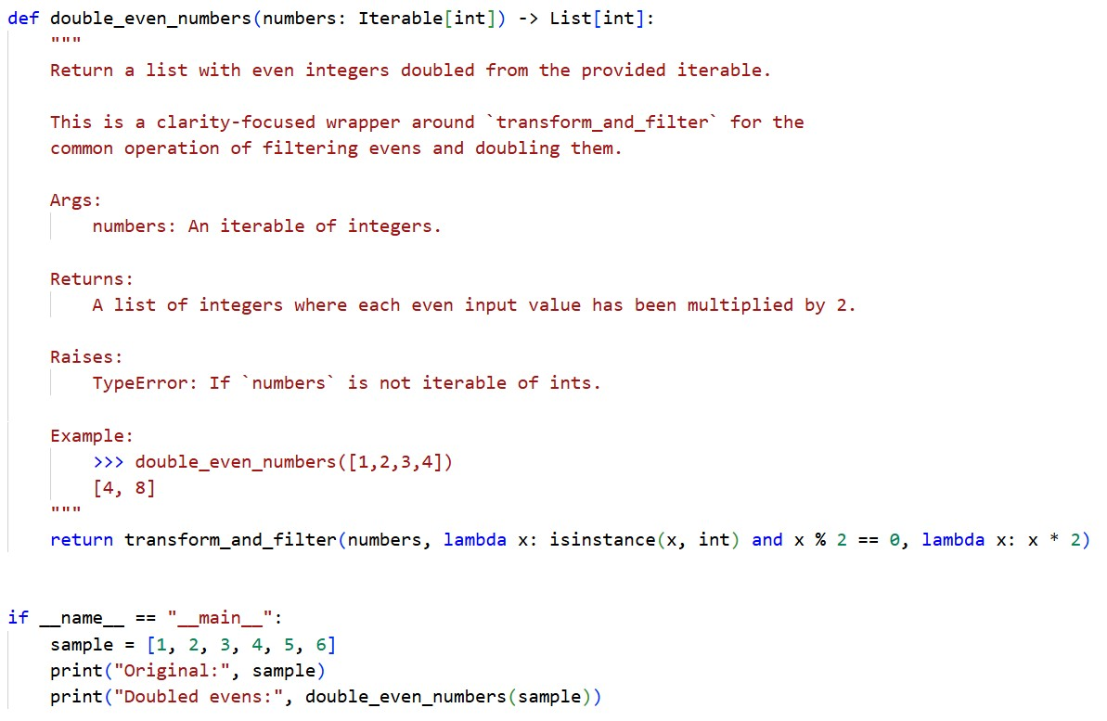

Output:
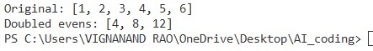
Justification:
Suggestions for generalization:
- Accept a max_items parameter for streaming/large iterables.
- Return an iterator (use yield) instead of a list for memory efficiency.
- Provide common predicates/transformers (e.g., is_even, scale_by(n)) in a small utilities module.
- Allow async predicates/transformers for IO-bound transforms.
AI should act as an assistant rather than a standalone reviewer. While it is efficient at detecting errors and enforcing standards, human reviewers provide critical thinking, context understanding, and design judgment. Combining AI speed with human insight leads to better and more reliable code reviews.

Task 5: AI-Assisted Performance Optimization
Prompt:
Analyze the given code, give time complexity, and then optimize the code and check for input range 1000000.
Code:
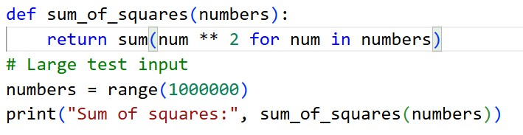

Output:
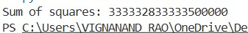
Justification:
Both the codes before and after optimization, it gives the same time complexity of O(n) as we must iterate till n number of times for getting the answer. We are optimizing the given code by using the in-built functions which helps to solve the problem easily.
Readable code helps humans understand, maintain, and debug programs easily. Highly optimized code may run faster but can become complex and harder to understand. So, it’s better to keep code simple and only optimize when performance is really needed.

